What are Fungal Nails?  Fungal nail infections are common and can affect both the fingernails and the toenails. The problem usually affects more men than women and becomes more common the older you become.  A fungal nail infection causes visual changes to the nail. It causes the nail to change colour, thicken and become brittle. As the infection progresses the nails will start to produce a distinct odour.  Around half of all nail problems are due to fungal nail infections.  What causes it?  Fungi called Dermatophytes live harmlessly on the skin but can often multiply and lead to infection in dark, warm and moist environments such as the feet. Certain shoes can cause the feet to become hot and sweaty which can lead the fungi to multiply quickly. Not keeping the feet clean and dry can also speed up the infection risk. |  |  | Where are we?  Address  Covering Sunderland, Washington, Seaham &  surrounding areas, South Shields, Boldon, Cleadon, Whitburn, Houghton le Spring and surrounding areas, Hetton, Penshaw, Shiney Row,  Wardley in Gateshead, etc.  Contact Us  Phone: 0191 5140817 or 07935039600  Email: themobilefootclinic@yahoo.com  Web: www.themobilefootclinic.net  themobilefootclinicsunderland  twitter.com/mobilefoot  themobilefootclinicsunderland |  |  |  | Fungal Nails  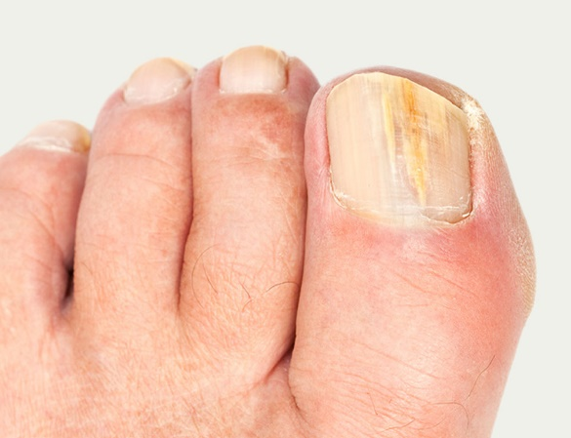  www.themobilefootclinic.net
What will happen if I leave it untreated?  The infection will progress if left untreated. The nail can become discoloured with the nail turning white, yellow, green or even black. The nail can become thickened and the texture can change making it difficult to trim. The shape of the nail can also change which can cause discomfort when placing pressure on the toes that are affected.  What can help?  Keeping feet clean and dry can help to reduce the risk of developing a fungal nail infection. Wearing shoes made from natural materials and cotton socks will allow the feet to breathe.  Fungal residue can build up in towels and socks, therefore, it is very important that they are washed regularly and not shared with others. |  |  |  | What are the treatment options?  There is a choice of either oral or topical anti-fungal treatments.  Oral anti-fungal treatments can be prescribed by your GP if you are suitable.  Topical treatments are available over the counter or from your podiatrist. Fungal nails infections can take a long time to resolve (Twelve months+), but the proper preparation of the nail surface by a podiatrist prior to applying the topical agent can increase the success.  www.themobilefootclinic.net |  |  | What is the Mobile Foot Clinic?  The Mobile Foot Clinic offers a mobile service to the public providing a range of foot care treatments. Following treatment a gentle foot massage is carried out. Where appropriate, clients are advised on ways to prevent future foot problems.  The Mobile Foot Clinic has been established since 2007, covering Sunderland, Tyne and Wear and surrounding areas.  A qualified Podiatrist, Lynn Ward runs and owns The Mobile Foot Clinic.  Find out more via my website:  www.themobilefootclinic.net

