What is Plantar Fasciitis?  Plantar Fasciitis means inflammation of your plantar fascia. Your plantar fascia is a strong band of tissue (like a ligament) that stretches from your heel to your middle foot bones. It supports the arch of your foot and also acts as a shock-absorber in your foot. Patients report a stabbing sensation when they take their first steps in the morning.  Plantar Fasciitis is one of the most common causes of heel pain and tends to be more common in runners.  What causes it?  Plantar Fasciitis is caused by abnormal forces on the foot. Contributing factors are obesity, weight gain, jobs that require a lot of walking or standing on hard surfaces, badly worn shoes with little support, and also inactivity.  As a result of these forces, with every step the Plantar Fascia (band of tissue under the foot) is being stretched, resulting in inflammation, irritation and pain at the attachment of the fascia into the heel bone. In some cases the pain is felt under the foot, in the arch. |  |  | Where are we?  Address  Covering Sunderland, Washington, Seaham &  surrounding areas, South Shields, Boldon, Cleadon, Whitburn, Houghton le Spring and surrounding areas, Hetton, Penshaw, Shiney Row,  Wardley in Gateshead, etc.  Contact Us  Phone: 0191 5140817 or 07935039600  Email: themobilefootclinic@yahoo.com  Web: www.themobilefootclinic.net  themobilefootclinicsunderland  twitter.com/mobilefoot  themobilefootclinicsunderland |  |  |  | Plantar Fasciitis  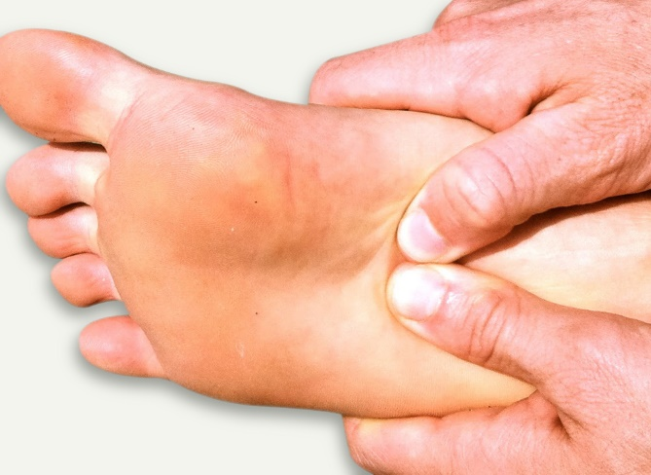  www.themobilefootclinic.net
What will happen if I leave it untreated?  If you ignore your symptoms you are at risk of developing chronic heel pain. Patients who experience long term foot pain tend to alter their gait to reduce the pressure on the affected area.  Long term this can cause to problems with the rest of the foot, the knees, the hips and the back.  What can help?  Most people can recover from Plantar Fasciitis with rest, icing the painful area, stretches and taking NSAID’s to relieve the pain and reduce the inflammation. |  |  |  | What are the treatment options?  If treated early (i.e. within 3-4 months of the onset of heel pain) Plantar Fasciitis can be treated effectively by wearing orthotic insoles.  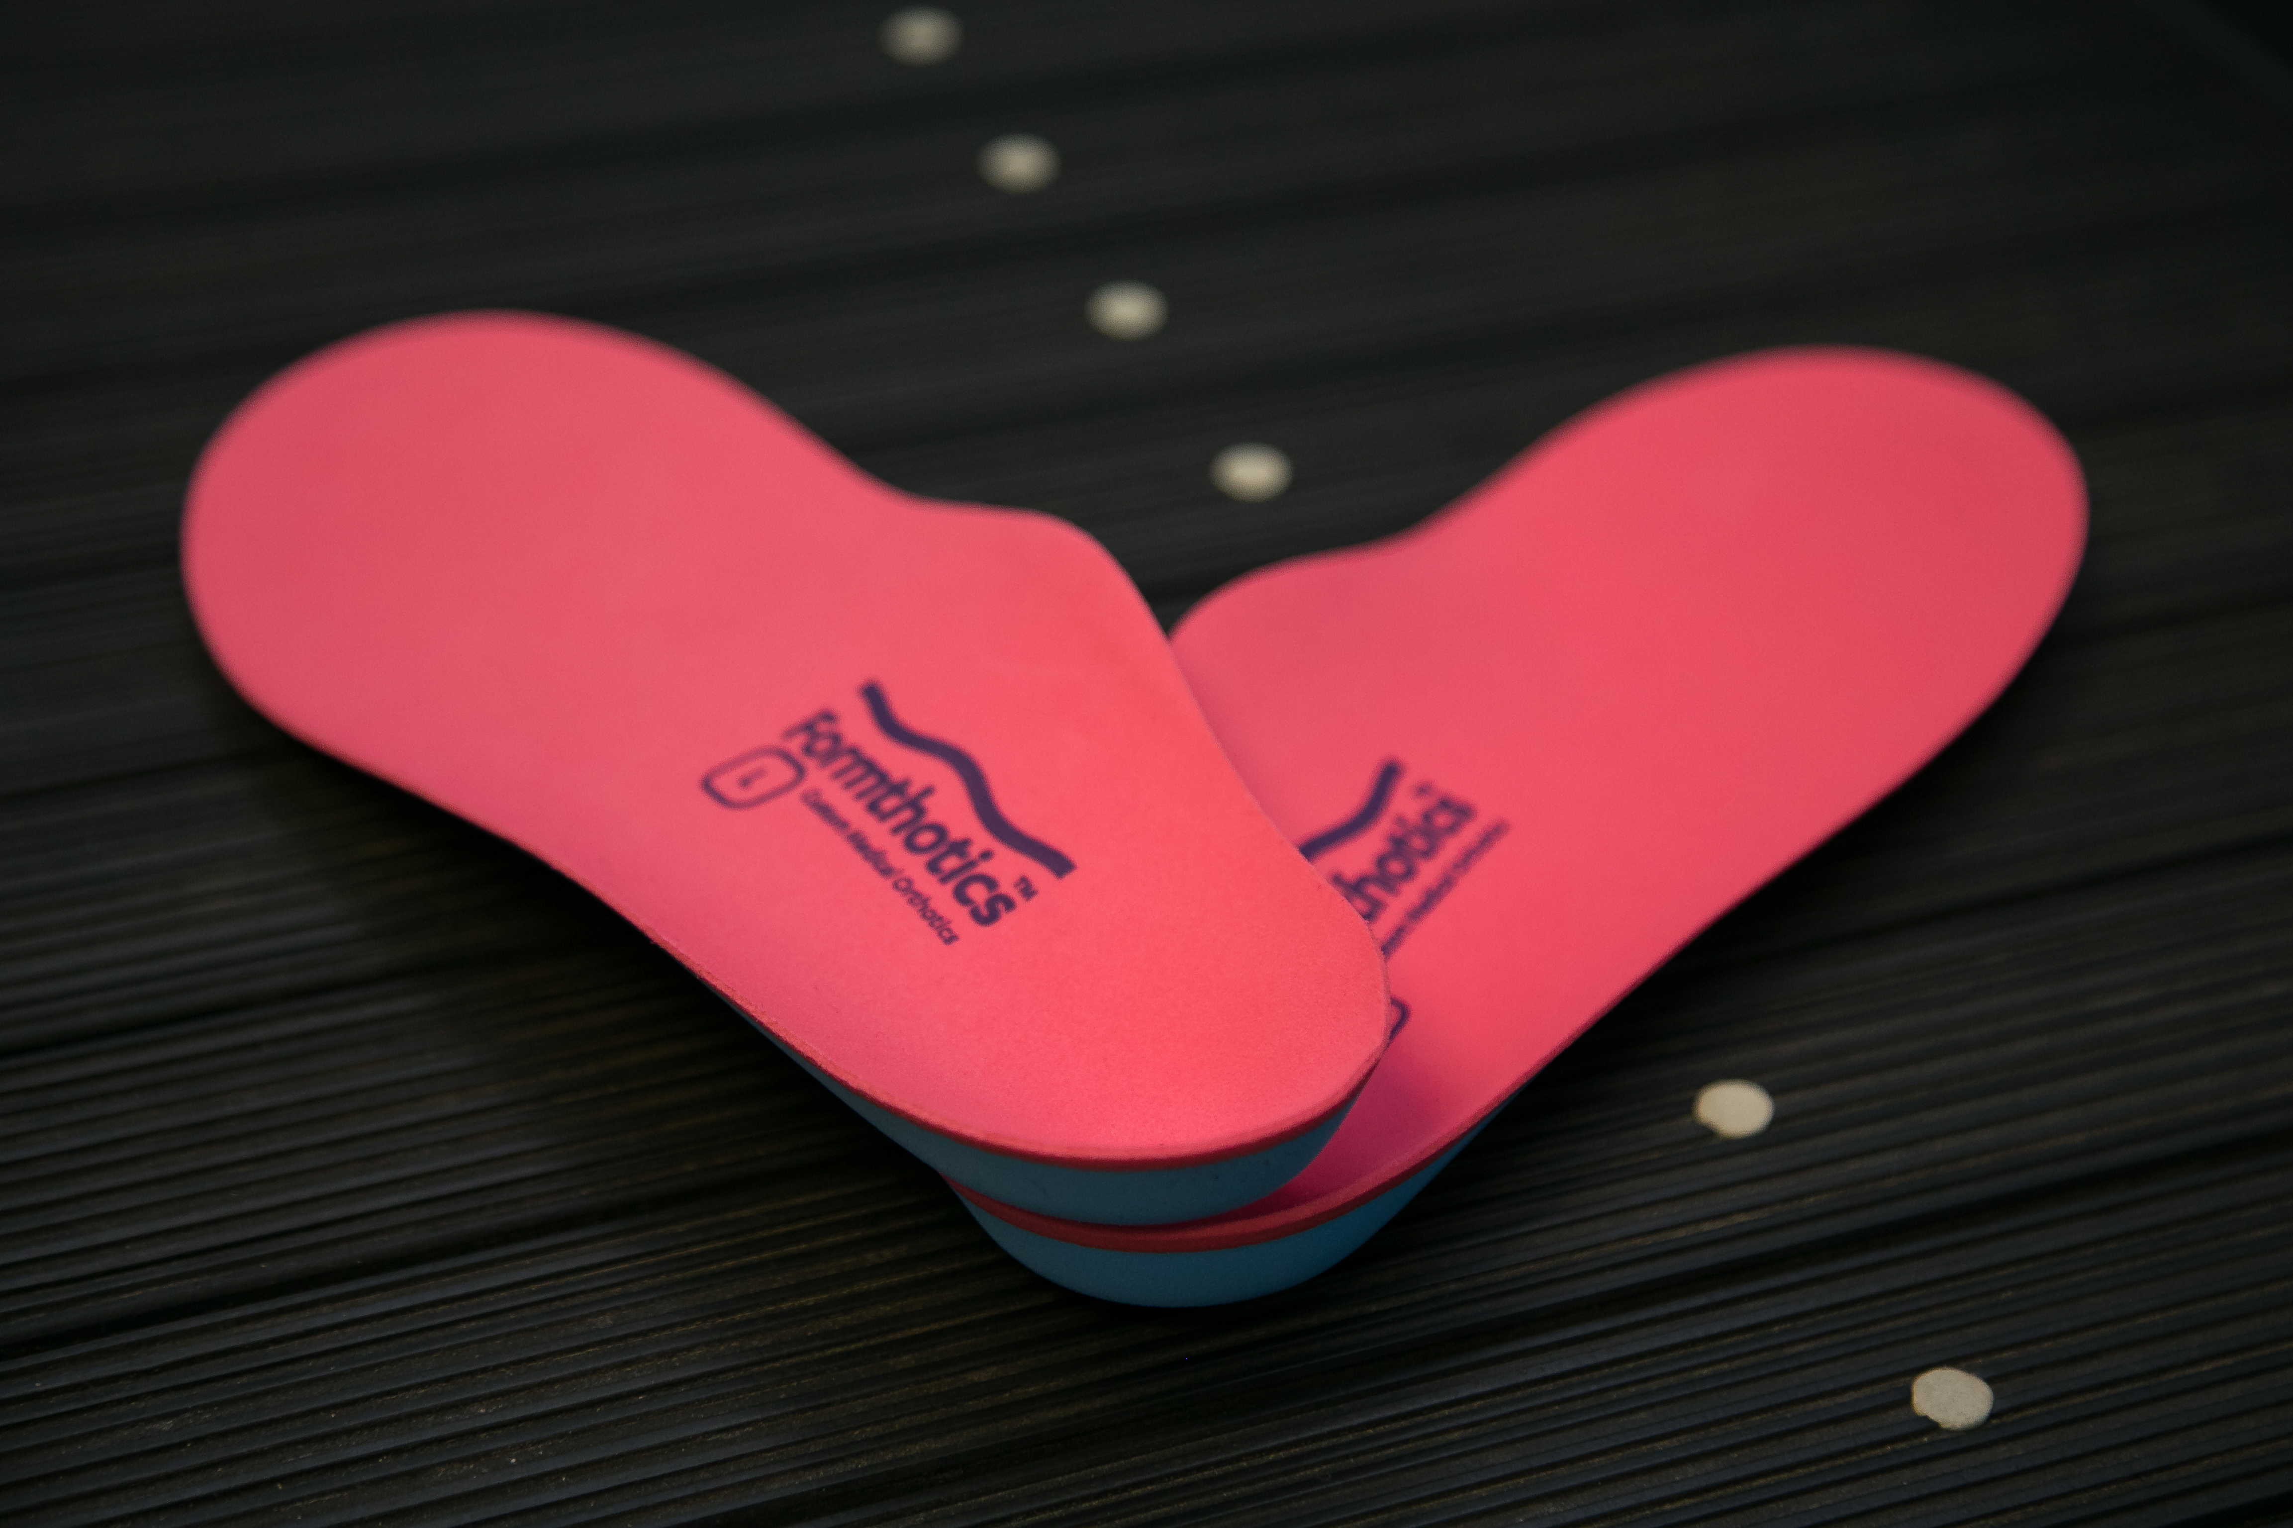  Orthotics can correct over-pronation and support the arch. This will help release the tension on the plantar fascia, thus treating the cause of Plantar Fasciitis.  www.themobilefootclinic.net |  |  | What is the Mobile Foot Clinic?  The Mobile Foot Clinic offers a mobile service to the public providing a range of foot care treatments. Following treatment a gentle foot massage is carried out. Where appropriate, clients are advised on ways to prevent future foot problems.  The Mobile Foot Clinic has been established since 2007, covering Sunderland, Tyne and Wear and surrounding areas.  A qualified Podiatrist, Lynn Ward runs and owns The Mobile Foot Clinic.  Find out more via my website:  www.themobilefootclinic.net

