What is a Verruca?  A Verrucae is usually found on the bottom of the foot and is a small skin lesion usually around 1cm in diameter.  Usually associated with children, verrucae are also a common complaint amongst adults.  What causes it?  All verrucae are caused by the human papilloma virus which is common in all environments but does not readily attack the skin. Due to this though verrucae are commonly contracted in communal places such as swimming pools, showers and changing areas, this is why children are more at risk of contracting verrucae’s in school changing rooms and swimming pools.  If there is excessive moisture or excessive dryness of the skin this can lead to small cracks in the skin which allows the virus to enter. |  |  | Where are we?  Address  Covering Sunderland, Washington, Seaham &  surrounding areas, South Shields, Boldon, Cleadon, Whitburn, Houghton le Spring and surrounding areas, Hetton, Penshaw, Shiney Row,  Wardley in Gateshead, etc.  Contact Us  Phone: 0191 5140817 or 07935039600  Email: themobilefootclinic@yahoo.com  Web: www.themobilefootclinic.net  themobilefootclinicsunderland  twitter.com/mobilefoot  themobilefootclinicsunderland |  |  |  | 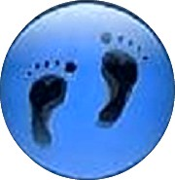  Verrucae  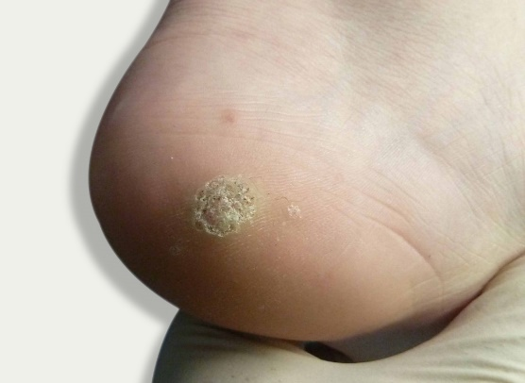  www.themobilefootclinic.net
What will happen if I leave it untreated?  Most of the time Verrucae will heal on their own if left alone however they can easily spread so if the verruca is touched or scratched a sufferer must wash their hands straight away or it can spread to other parts of the body.  What can help?  To avoid verrucae, try to avoid touching other people's verrucae and that hands are washed if a verruca is touched. It is also best to avoid sharing towels, flannels, shoes and socks with other people and to make sure that feet and hands are kept clean and dry.  Due to how the virus spreads it is best to avoid going barefoot in public places and communal areas.  Also, if contracted avoid scratching or picking at the verruca this may spread the infection to other parts of the body. |  |  |  | What are the treatment options?  Verrucae can be removed with over-the-counter treatments, but these don't always work. The treatments include things like creams, gels, skin paints and medicated plasters containing salicylic acid, the salicylic acid is used to burn the top layer of the affected skin. You can also find cold sprays that contain dimethyl ether propane, these sprays are used to freeze the wart.  Your Podiatrist may be able to offer a procedure known as needling which is carried out under a local anaesthetic.  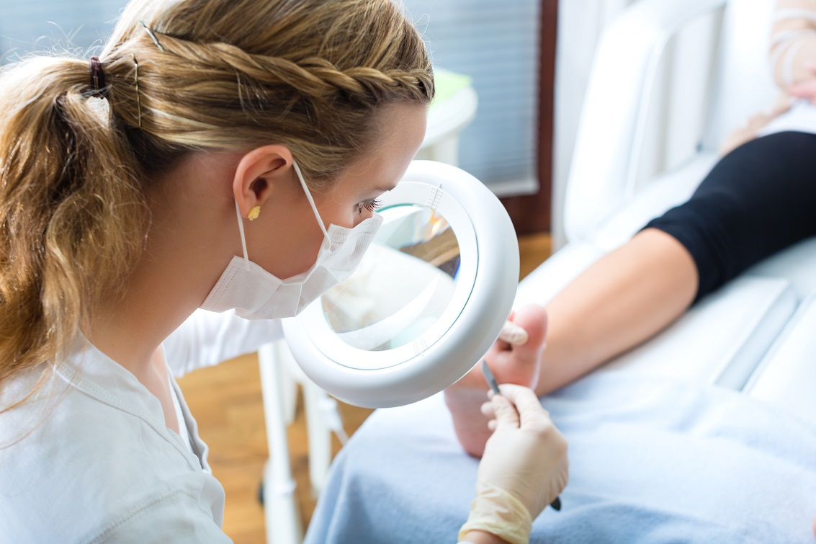  Www.themobilefootclinic.net |  |  | What is the Mobile Foot Clinic?  The Mobile Foot Clinic offers a mobile service to the public providing a range of foot care treatments. Following treatment a gentle foot massage is carried out. Where appropriate, clients are advised on ways to prevent future foot problems.  The Mobile Foot Clinic has been established since 2007, covering Sunderland, Tyne and Wear and surrounding areas.  A qualified Podiatrist, Lynn Ward runs and owns The Mobile Foot Clinic.  Find out more via my website:  www.themobilefootclinic.net

