What are Bunions?  Bunions are bony lumps that develop on the joint at the base of the big toe and can be very painful.  A bunion can cause the big toe to point towards the other toes on the foot often leading to an overlap of the big toe and the second toe.  A bursa, which will appear red and swollen, can sometimes form on the joint.  What causes it?  Genetics play as large part of the development of a bunion. If you have a family member that suffers from bunions your risk of developing them will increase. However, this doesn't mean you'll necessarily develop them.  Existing bunions can be made worse but wearing shoes that are too tight or don’t fit well.  Arthritic conditions such as rheumatoid arthritis and psoriatic arthritis can increase the likelihood of you developing a bunion. |  |  | Where are we?  Address  Covering Sunderland, Washington, Seaham &  surrounding areas, South Shields, Boldon, Cleadon, Whitburn, Houghton le Spring and surrounding areas, Hetton, Penshaw, Shiney Row,  Wardley in Gateshead, etc.  Contact Us  Phone: 0191 5140817 or 07935039600  Email: themobilefootclinic@yahoo.com  Web: www.themobilefootclinic.net  themobilefootclinicsunderland  twitter.com/mobilefoot  themobilefootclinicsunderland |  |  |  | 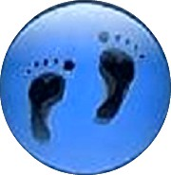  Bunions  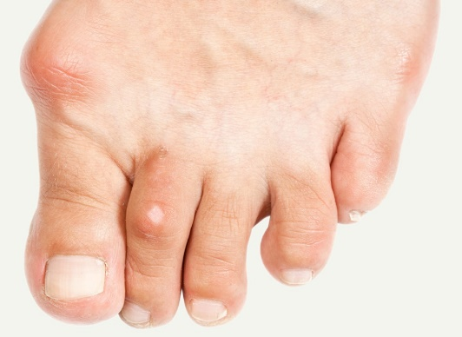  www.themobilefootclinic.net
What will happen if I leave it untreated?  If left untreated the symptoms can worsen over time. In severe cases, the bunion can continue to develop until surgery is the only treatment option.  It is recommended to seek treatment in the early stages to prevent the symptoms from worsening.  What can help?  Footwear can be a great help to those suffering from bunions. Shoes with adequate width are recommended as this can help to prevent the shoe from rubbing against the bunion. You may find that a shoe fastened with a strap is more comfortable. High heels can aggravate the bunion due to the tight fit.  The golden rule to shoe fitting is to make sure that your shoes are the correct size and that there's enough room to move your toes freely. |  |  |  | What are the treatment options?  Non-surgical treatment is always recommended in the first instance. If your bunion is painful, over the counter painkillers such as ibuprofen or paracetamol may be recommended. A Bunion pad may also be recommended to ease the pain.  An orthotics device may be prescribed by your Podiatrist to offer stability around the joint. Unfortunately, an orthotic device cannot reverse the damage to the bone structure but, when used in appropriate footwear, it can provide pain relief when walking for many.  In more serious cases, your Podiatrist may recommend surgery.  www.themobilefootclinic.net |  |  | What is the Mobile Foot Clinic?  The Mobile Foot Clinic offers a mobile service to the public providing a range of foot care treatments. Following treatment a gentle foot massage is carried out. Where appropriate, clients are advised on ways to prevent future foot problems.  The Mobile Foot Clinic has been established since 2007, covering Sunderland, Tyne and Wear and surrounding areas.  A qualified Podiatrist, Lynn Ward runs and owns The Mobile Foot Clinic.  Find out more via my website:  www.themobilefootclinic.net

