What are Corns and Callus?  Corns are small areas of thickened skin often in a circular shape. Most commonly they develop on the sole of the foot or on the tops of the toes. Calluses are rough areas of skin that are hard and often appear yellow in colour. Calluses are thick and less sensitive to touch than the surrounding skin.  Corns and calluses often develop on the feet and can cause pain and discomfort when walking.  What causes it?  The main cause of corns and calluses is excessive pressure. Footwear which rubs the foot or if you are a runner, sportsman / woman etc. involved in high levels of activity, corns and calluses develop due to the pressure caused during movement. The response from the skin is to produce hardened parts of skin which then form into either corns or calluses. |  |  | Where are we?  Address  Covering Sunderland, Washington, Seaham &  surrounding areas, South Shields, Boldon, Cleadon, Whitburn, Houghton le Spring and surrounding areas, Hetton, Penshaw, Shiney Row,  Wardley in Gateshead, etc.  Contact Us  Phone: 0191 5140817 or 07935039600  Email: themobilefootclinic@yahoo.com  Web: www.themobilefootclinic.net  themobilefootclinicsunderland  twitter.com/mobilefoot  themobilefootclinicsunderland |  |  |  | 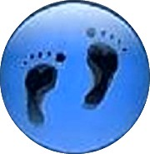  Corns and Callus  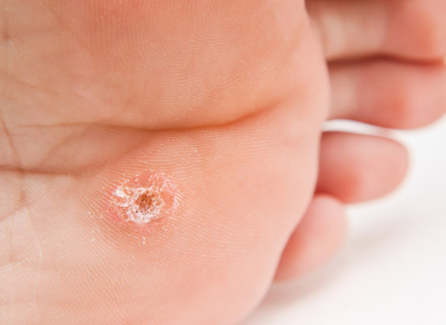  www.themobilefootclinic.net
What will happen if I leave it untreated?  If corns and calluses are left untreated the hard skin will continue to build up and become more painful.  Additionally, if the causes of the corns and calluses on your feet i.e. the pressure, are not removed the corns and calluses will not get better and may well return even after treatment.  What can help?  Footwear choices can be a great prevention tool for corns and calluses. Pressure is the main causes of corns and calluses and by removing the pressure it can prevent the corns and calluses from forming.  High heels increase the pressure placed on the front of your feet and can therefore increase the likelihood of corns and calluses developing.  Drying your feet thoroughly after washing them and regularly applying moisturisng cream can also help to prevent the formation of calluses and corns. A pumice stone or a foot file can also help to gently remove the build up of hard skin that can occur on the feet. |  |  |  | What are the treatment options?  A Podiatrist is the first port of call for the treatment of corns and callus. A scalpel is used to remove corns and calluses painlessly.  The aim is to prevent corns and calluses from returning. This can often be achieved by changing your footwear and / or redistributing the pressure that is causing the corns and callus. Your Podiatrist can prescribe orthotics which can help to ease the pressure.  www.themobilefootclinic.net |  |  | What is the Mobile Foot Clinic?  The Mobile Foot Clinic offers a mobile service to the public providing a range of foot care treatments. Following treatment a gentle foot massage is carried out. Where appropriate, clients are advised on ways to prevent future foot problems.  The Mobile Foot Clinic has been established since 2007, covering Sunderland, Tyne and Wear and surrounding areas.  A qualified Podiatrist, Lynn Ward runs and owns The Mobile Foot Clinic.  Find out more via my website:  www.themobilefootclinic.net

